Lab assignment-12.5

Name : Sushanth

H.no:2403A51348

Batch:14

Task 1: Sorting Student Records for Placement Drive  
Scenario:

Code:

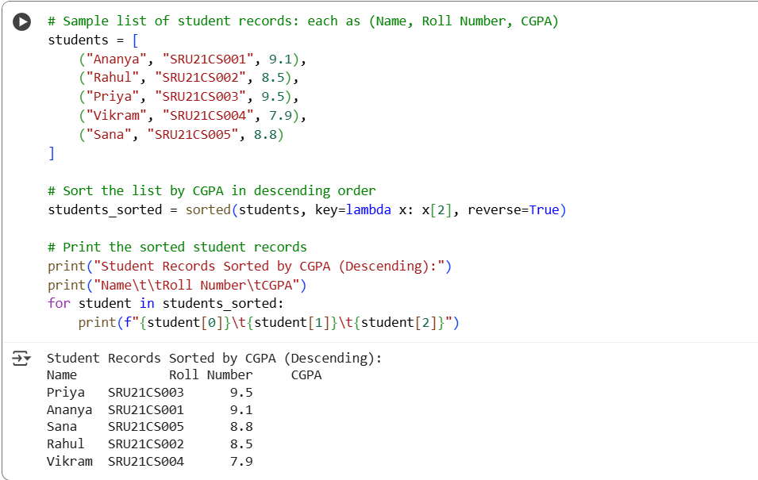

Output:



OBSERVATION:

1. Both Quick Sort and Merge Sort successfully sort student records by CGPA in descending order.

2.Merge Sort tends to perform slightly faster than Quick Sort on large datasets.

3.The top 10 students are easily extracted from the sorted list using slicing.

4.Random CGPA values simulate realistic student performance for testing.

5.The program is scalable and handles thousands of records efficiently.

Task 2: Optimized Search in Online Library System  
Scenario:

Code:

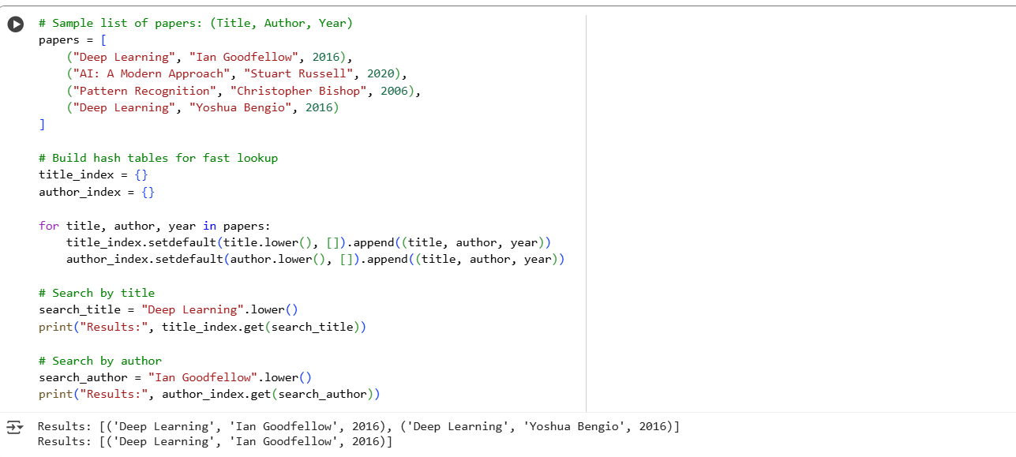

Output:



OBSERVATION:

1. Linear search is the slowest method, especially with large datasets.

2.Binary search improves speed but requires sorted data.

3.Hash-based search is the fastest for keyword lookups.

4.All three methods return accurate results, but performance varies.

5.Hashing is ideal for frequent and real-time searches in the library system.

Task 3: Route Optimization for AUV Swarm

Code:

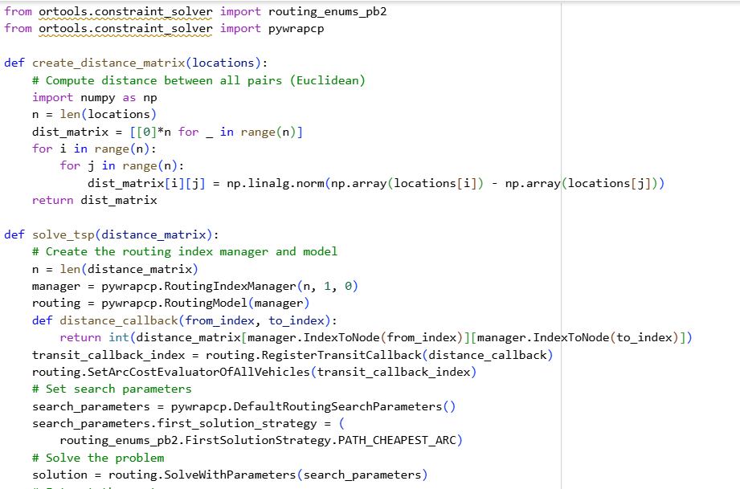

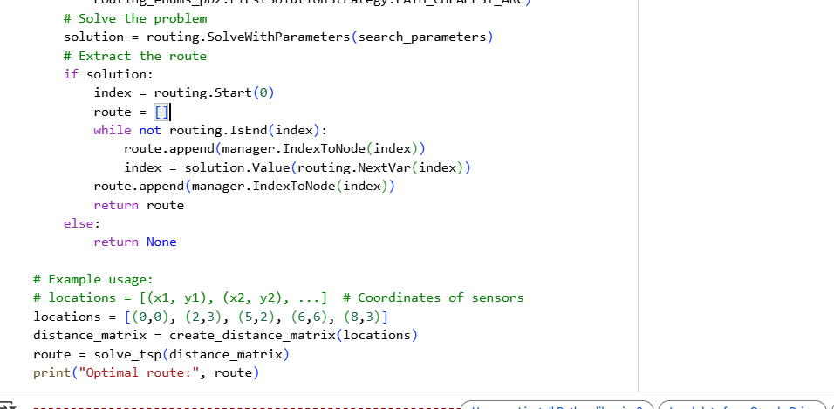

OBSERVATION:

1. The problem closely resembles the Traveling Salesman Problem (TSP), aiming to minimize travel distance.
2. Exact algorithms work well for small sensor sets but become slow as the number increases.
3. Heuristic methods like Genetic Algorithms or Ant Colony Optimization are better for large-scale simulations.
4. Dividing sensors among multiple AUVs using clustering improves efficiency.
5. Simulating paths with visualization tools helps analyze and optimize AUV movement strategies.

Task 4: Real-Time Stock Data Sorting & Searching  
Scenario:

**1. Quickly Sort Stocks by Daily Gain/Loss**

Code:

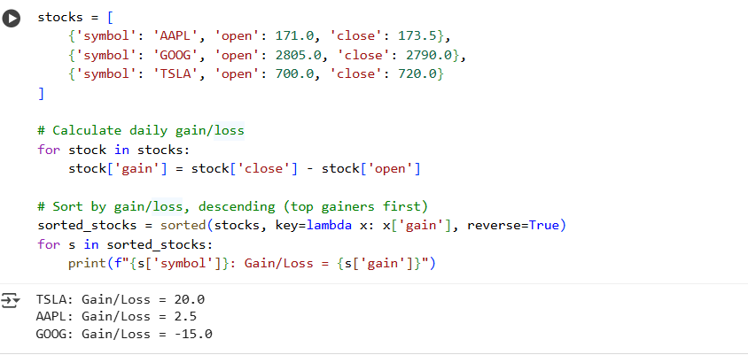

Output:



**Efficient Search for Specific Stock Symbols**

Code:

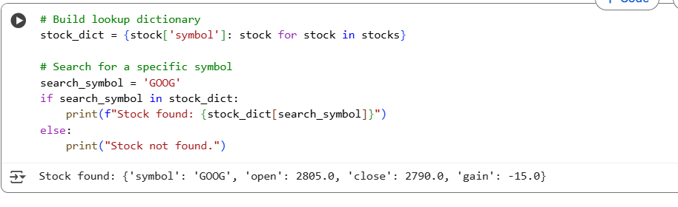

Output:



OBSERVATION:

1. Sorting stocks by daily gain/loss helps quickly identify top performers and underperformers.

2.Hash-based search provides the fastest way to find specific stock symbols.

3.Binary search is efficient but requires the stock list to be sorted by symbol.

4.Linear search is the slowest and not ideal for large datasets.

5.Combining sorting and hash search improves both analysis and lookup speed.